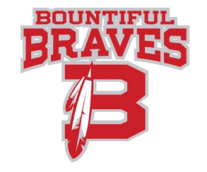

Bountiful High School-Community Council Agenda
Wednesday November 13, 2019

- Welcome and introductions
- Counselor Report
- Standards Based Learning
- Senate election process
- Hope Squad selection process
- Items from Community Council Members
- Next meeting: January 8, 2020

