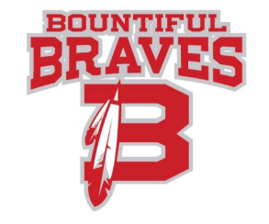

Bountiful High School-Community Council Agenda
Wednesday March 10, 2021

- Welcome
- Review of minutes from previous meeting, February 10, 2021

- COVID updates

  - Test for Prom?

- Mascot update

- 2021-22 Trustland Expenditure Proposals

- Counselor’s Report

- Teacher’s Report

- Items from Community Council Members

  - Question from last meeting about requiring students to take a theatre class to be involved in extra curricular theatre productions?
  - Explanation of the Summit program and available resources.
  - Can we set a goal of 95% student participation rate in at least one extra-curricular activity/sport/club?

- Next meeting: April 14, 2021

